**WEEK-05 ASSIGNMENT**

**Shoezy - E-commerce Shoe Website**

**Introduction:**

Shoezy is a modern e-commerce platform designed for users to explore and purchase stylish footwear. The platform features a seamless UI, a responsive design, and essential functionalities like product browsing, searching, adding items to the cart, and secure checkout.

**Features:**

* **Product Listing:** Displays available shoes in a grid format with images, titles, and prices.
* **Product Details:** Shows in-depth details of each shoe, including descriptions, pricing, and add-to-cart functionality.
* **Search Functionality:** Allows users to search for products using keywords.
* **Shopping Cart:** Users can add, remove, increase, and decrease product quantities.
* **Navigation Bar:** Provides easy access to the homepage, cart, and search functionality.
* **Hero Section:** Highlights featured products and brand messaging.
* **Footer Section:** Displays social media links and copyright information.

**Technologies Used:**

• **React.js** – Component-based UI development

• **React Router** – Routing for navigating between pages

• **Tailwind CSS** – Styling and responsiveness

• **React Icons** – For adding icons to the UI

**HOMEPAGE OUTPUT:**



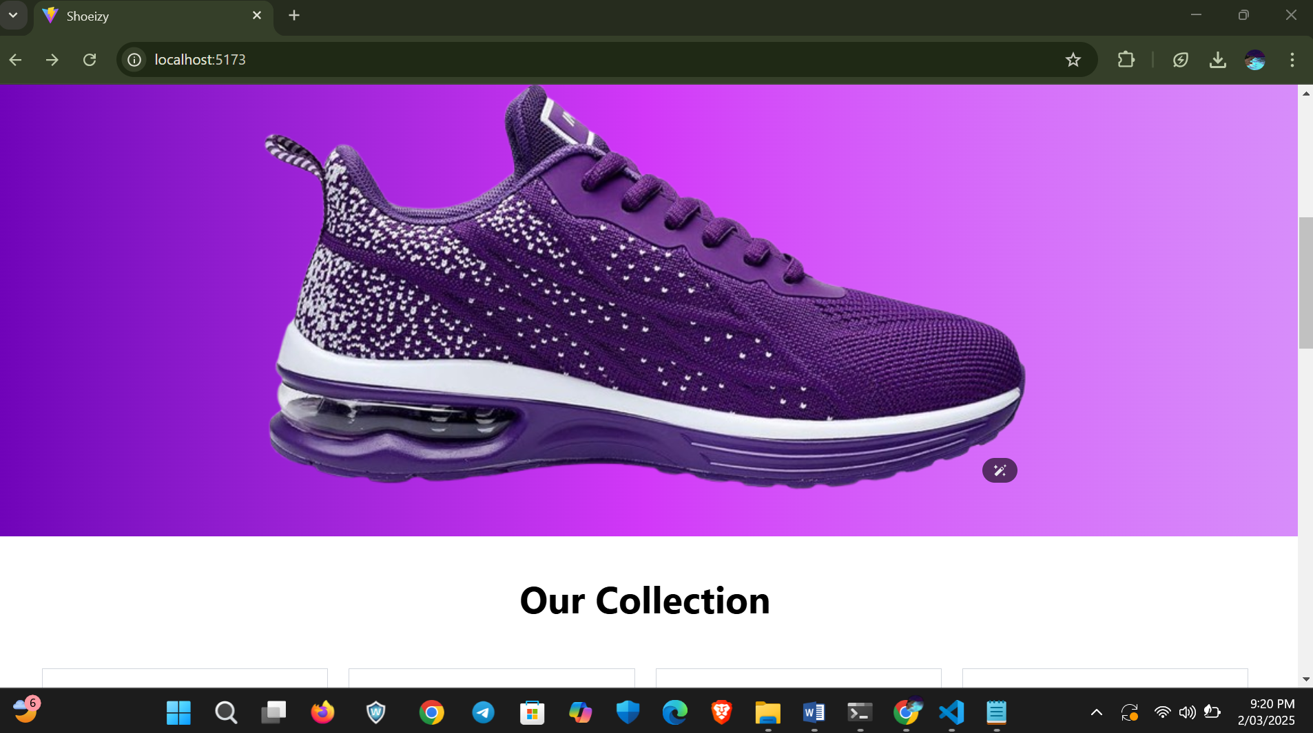

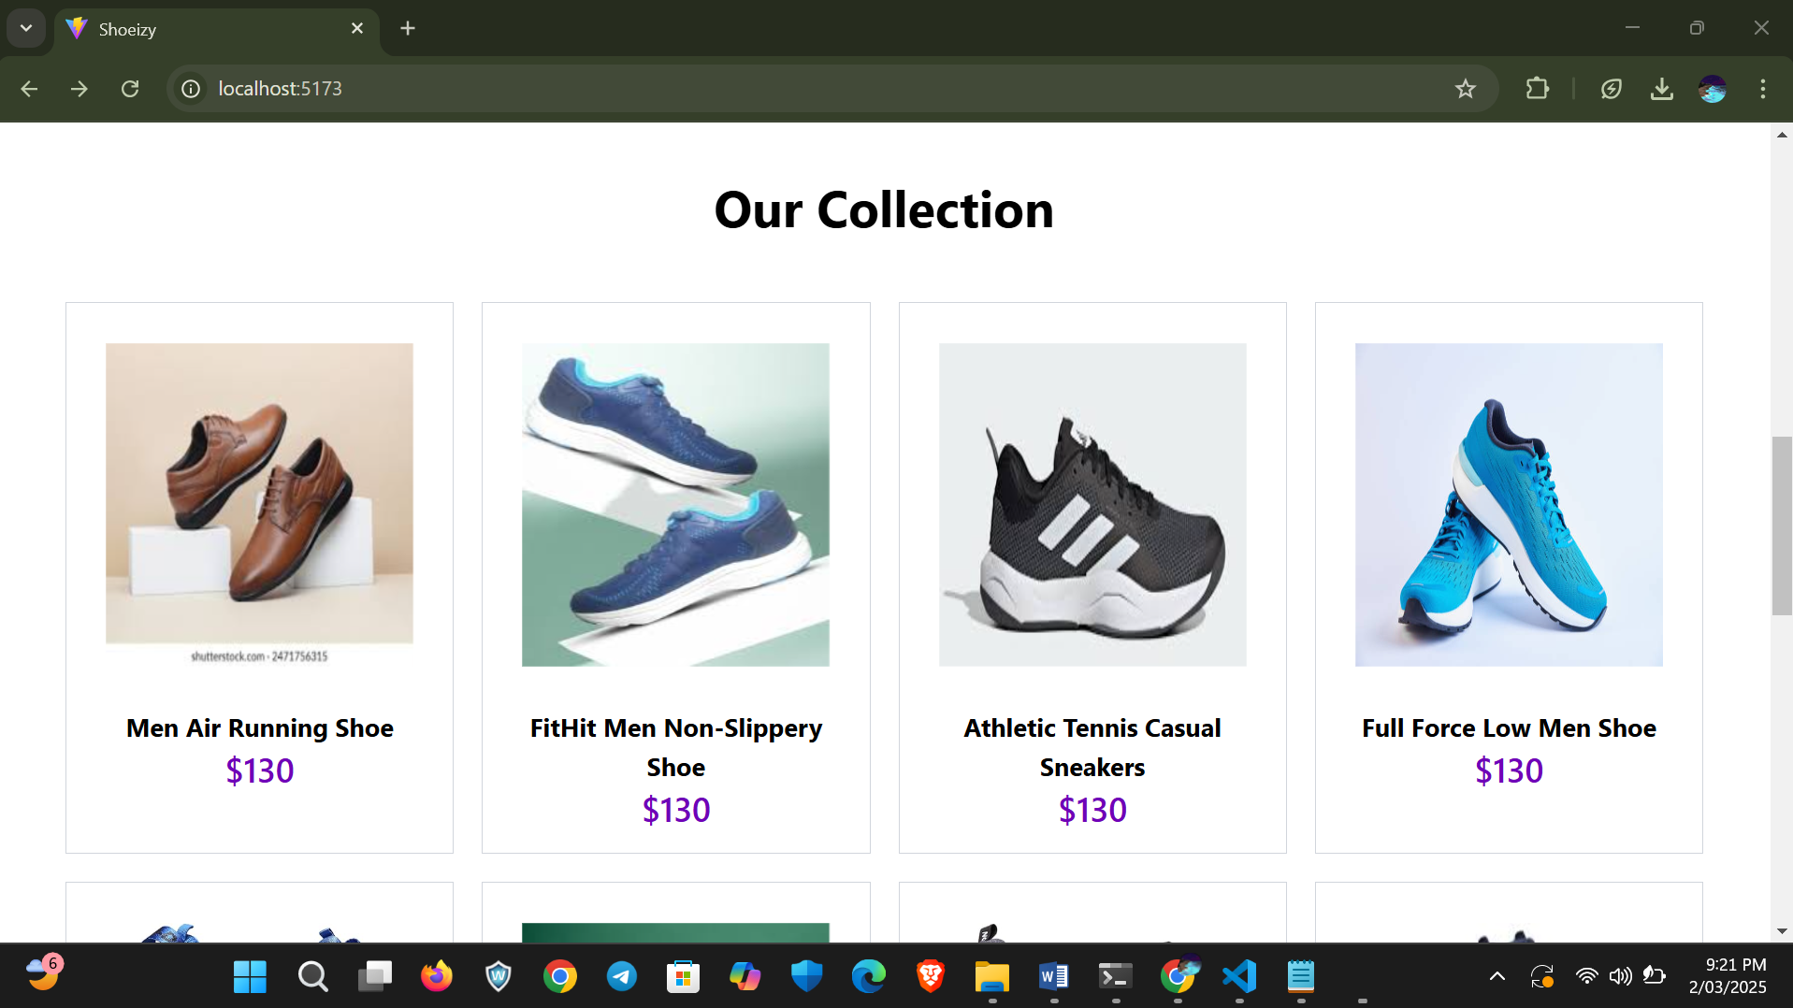

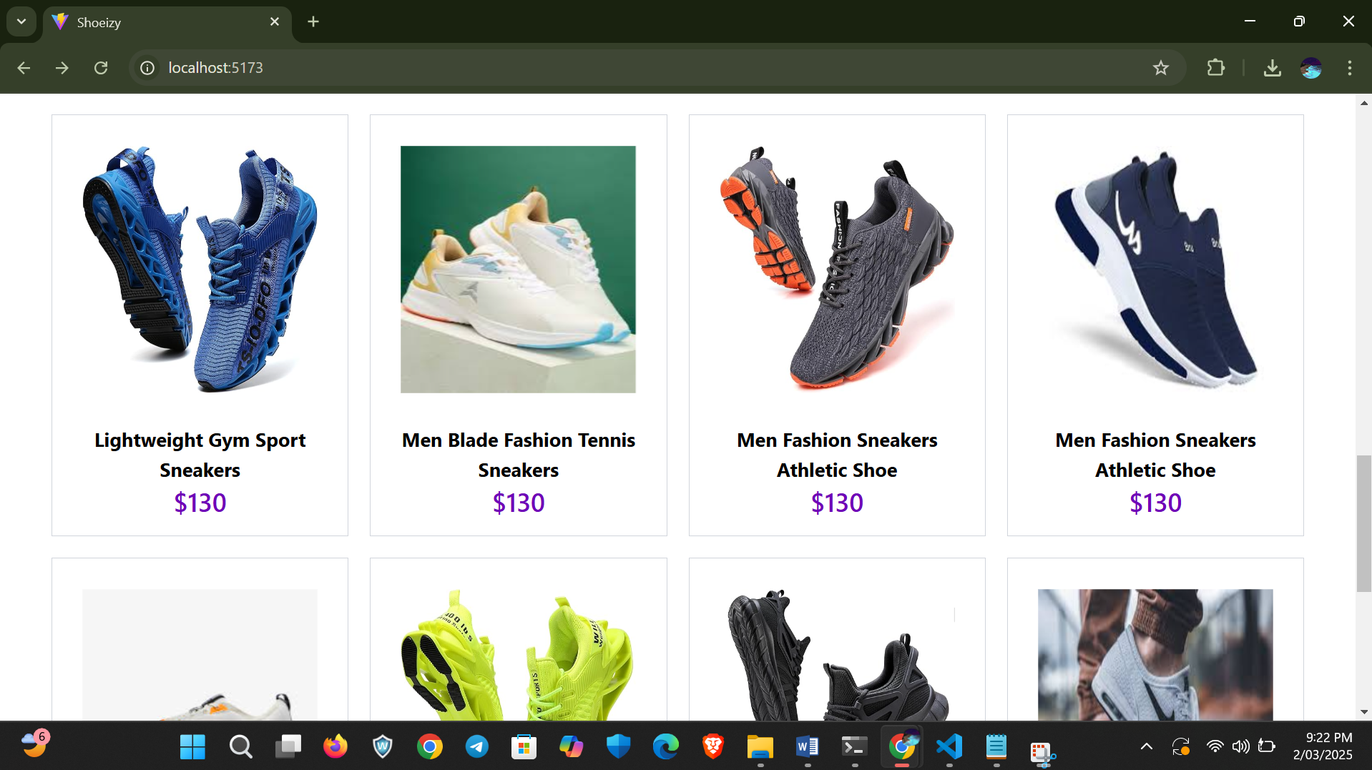

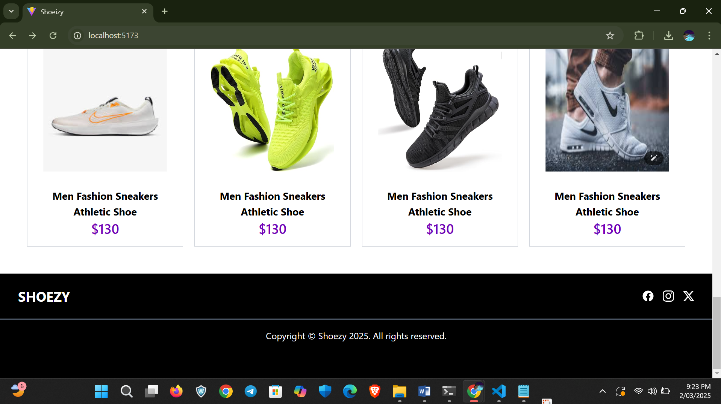

If I hover the mouse on a particular product it show us two icon which cart icon and eye icon

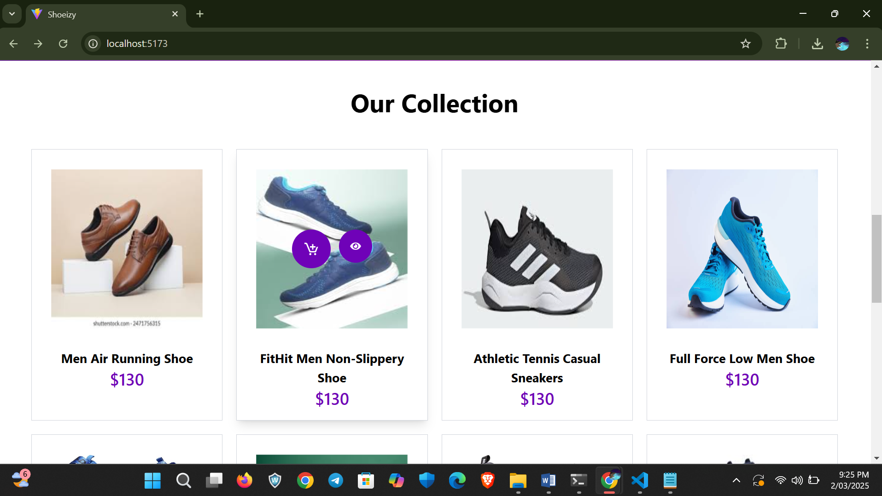

The eye icon represents the description of the product

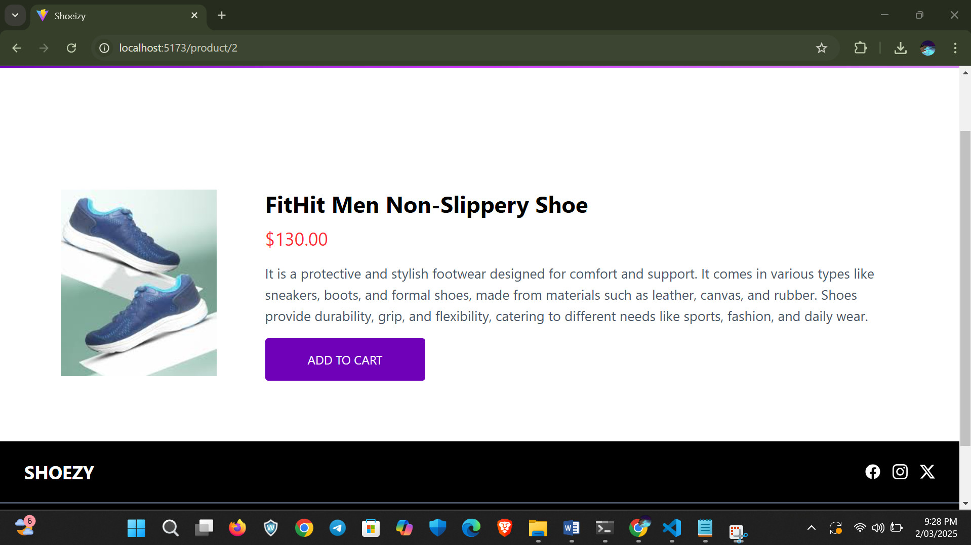

If we want to add a product to cart there is two ways which is we can directly add the product into cart and other one is knowning the description of that particular product

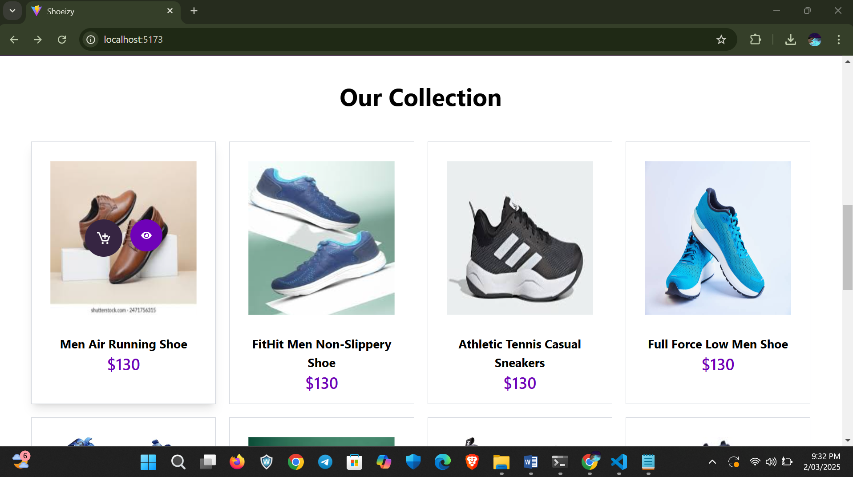

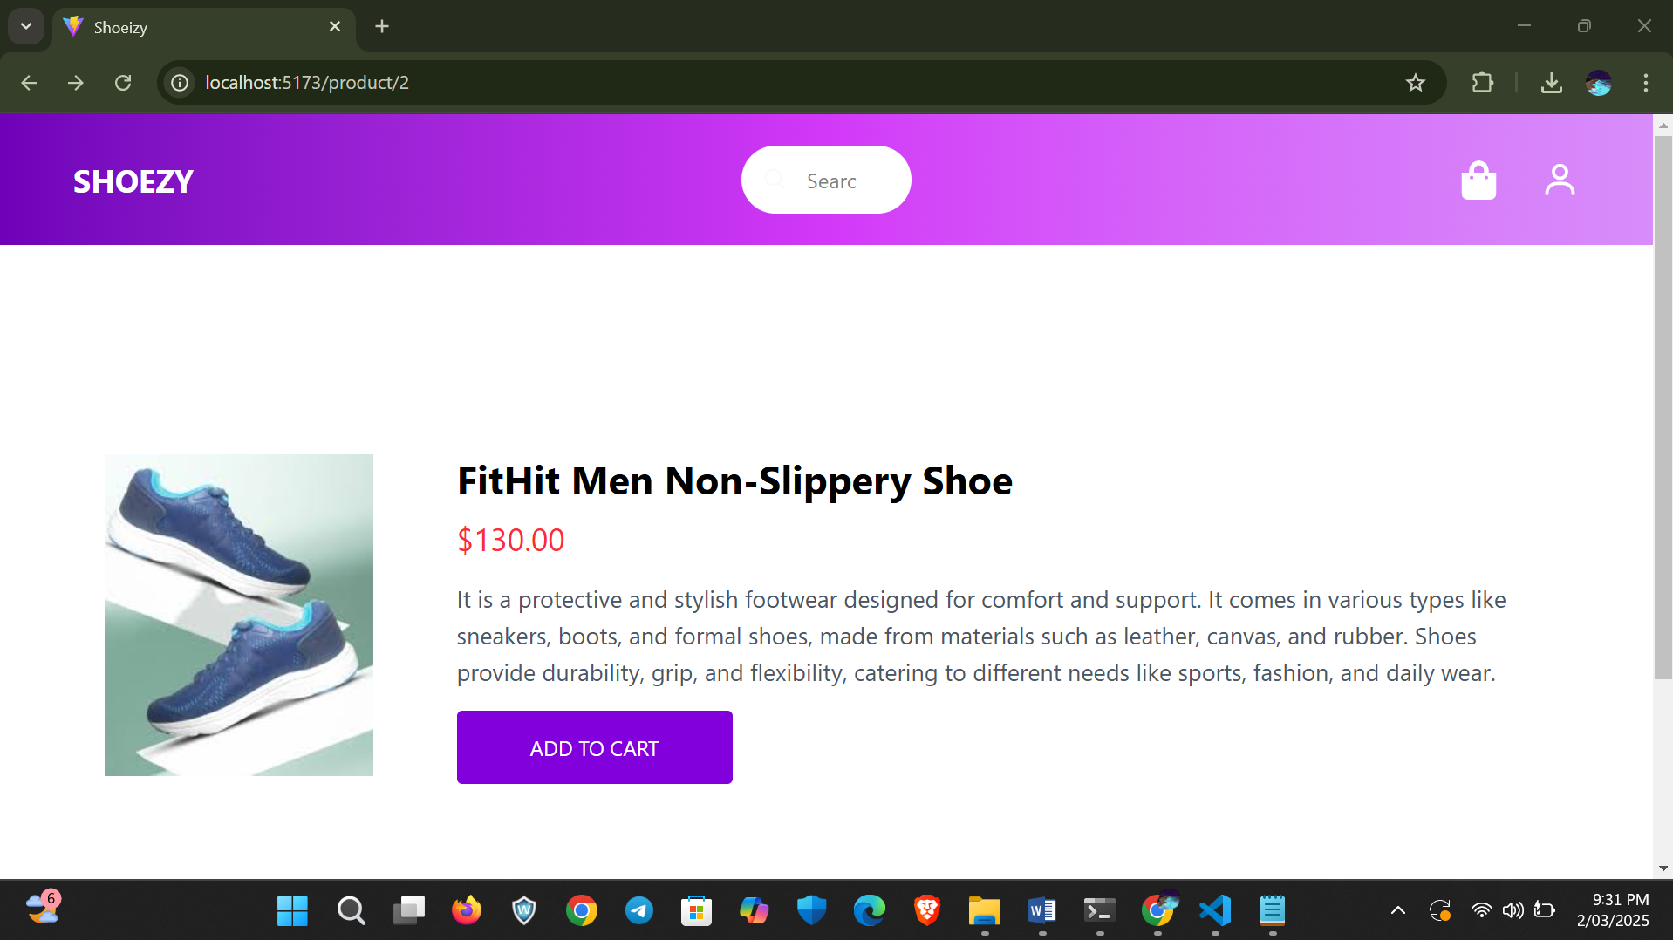

By adding products in your cart we can see that how many products are add in cart by looking at corner cart icon button which is it top right side of website.



By clicking the icon we are navigated to cart section where there is details of the product add and total amount to pay.

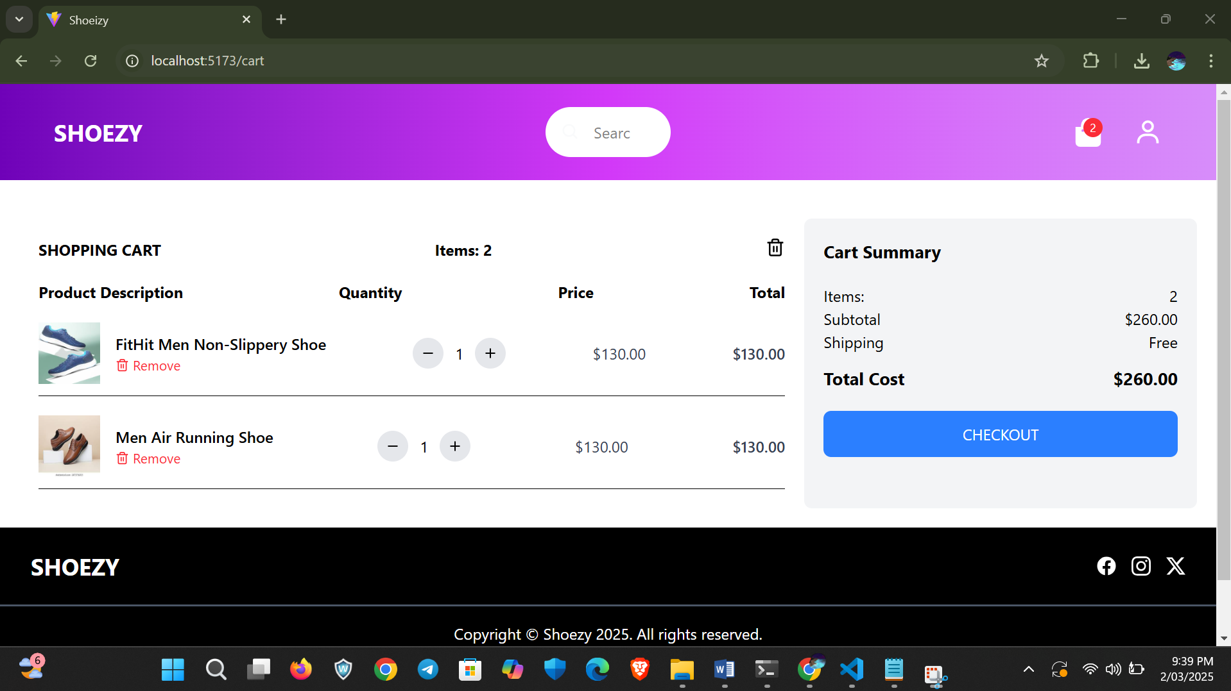

We can add how many of a particular product we needed by clicking quantity based quantity the total may get higher and we can also remove a product from cart by clicking the remove options present below every product.

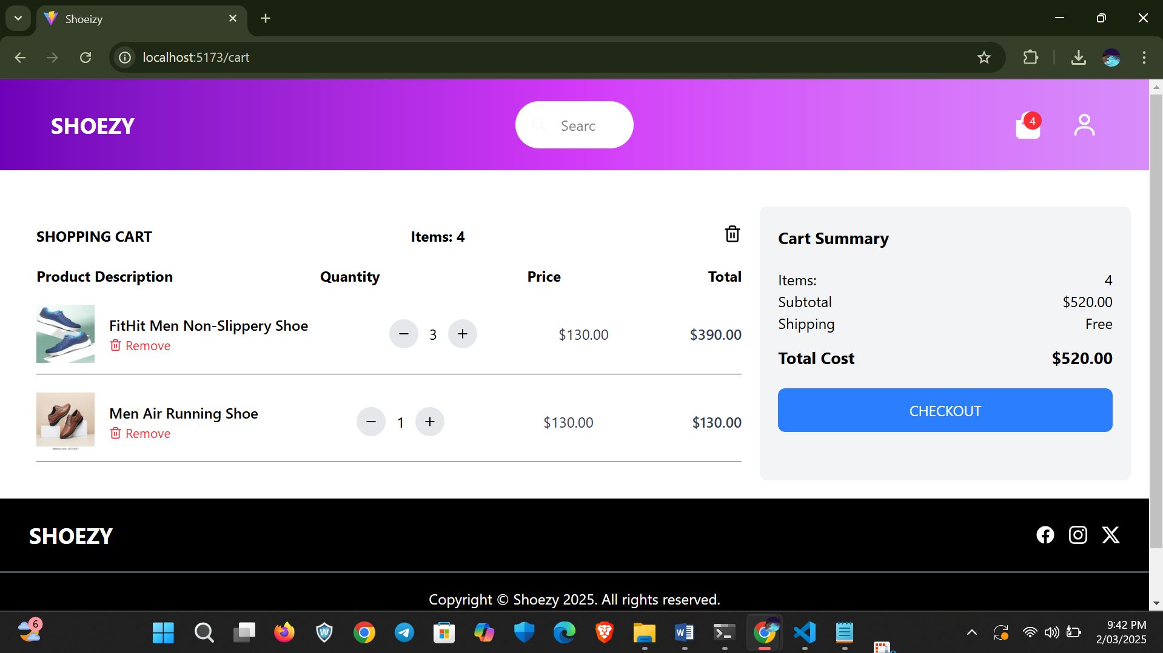

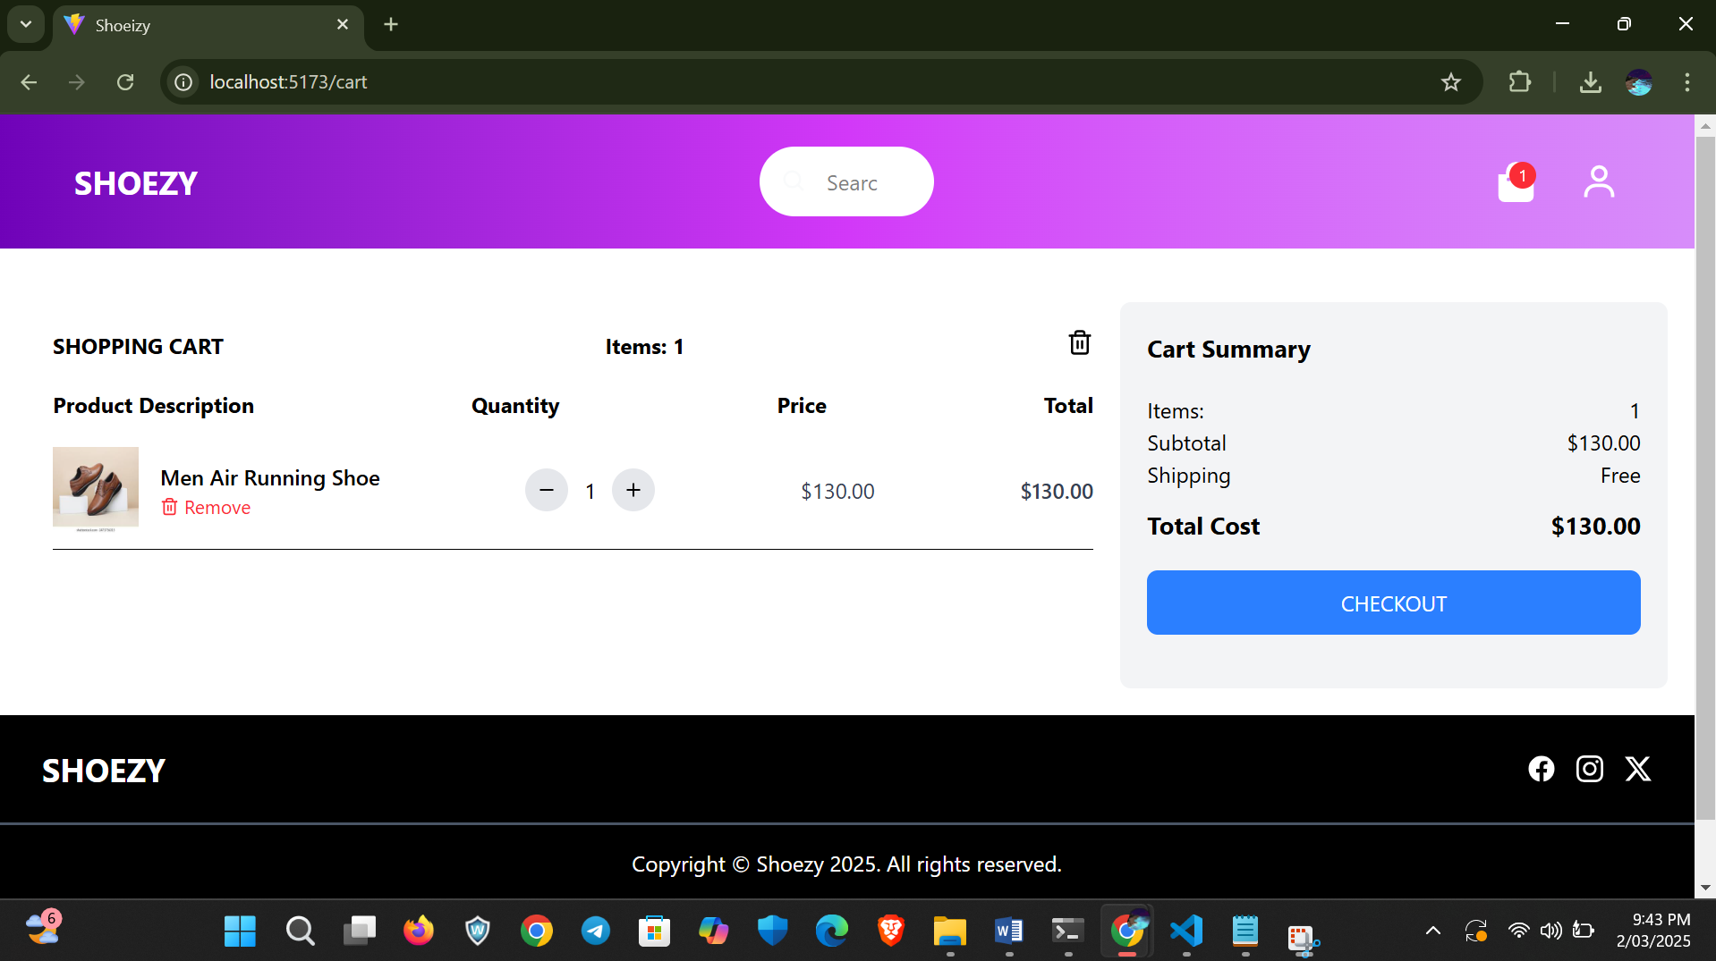

If we didn’t add any product to cart means it shows

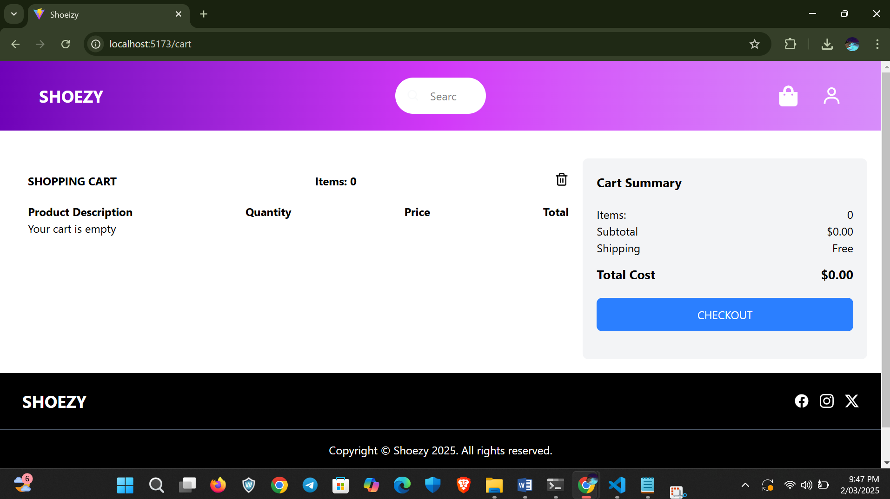

**Conclusion:**

Shoezy provides a simple and stylish platform for purchasing shoes online, offering a smooth user experience with easy navigation and cart management.